Home decoration new wind system and bad air goodbye

Nowadays more and more people are living in new houses, but these houses which you have saved for most of your life and even have to pay back the loan for several decades, you must spend some time on decoration, so that you can live healthily and safely for a long time.

What should we pay attention to when decorating?

As the old saying goes, "water is not rotten, but a door hinge is not worm eaten." The same is true of our indoor environment. Let the indoor air flow, not only for our house to add vitality, but also to avoid the harm of indoor air pollution, so that we can breathe a continuous stream of fresh air, can be said to be a killing.

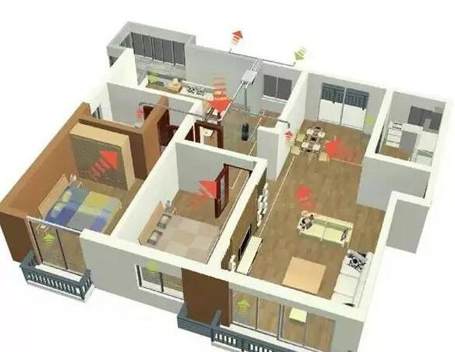

Fresh air system entered our country earlier in 1995, when the sky was still very blue outside, and the air was still fresh outside, which is still a window ventilation can alleviate indoor air pollution to a certain extent. Compared with open-window ventilation, fresh air system can organize air flow better, allowing fresh air and dirty air to move along specific paths. In addition, fresh air system can not be affected by bad weather environment. Fresh air is transported continuously 24 hours a year 365 days, which is incomparable with open-window ventilation.

But with the change of atmospheric environment, the fresh air system also needs to progress with the times. If we do not open the window, indoor air pollution will bring us a variety of diseases, dizziness, nausea, depression, drowsiness, low immunity, insomnia, and even leukemia; if we open the window, outdoor PM10, PM2.5, nitrogen oxides, hydrocarbons and other toxic substances will be hidden with the wind. Enter. The frequent warning of air pollution is also a test of the fresh air system. We must decompose and remove the pollutants at the source, that is, to "move" the air in the house, but also to "keep out" the pollutants outside.

Fresh air system for indoor air pollution problems, without opening windows can be ventilated, exhaust indoor harmful gases while introducing outdoor clean air, while filtering PM2.5, so that you stay away from the polluted living environment, eliminate the existence of indoor invisible killers, create a comprehensive green, give you and your children a healthy room Inner space. Make sure your house will breathe.

from: http://www.smoggo.net/xinwenzhongxin/gongsixinwen/16.html